**Krishna: Behavioral Cloning**

The goals / steps of this project are the following:

* Use the simulator to collect data of good driving behavior
* Build, a convolution neural network in Keras that predicts steering angles from images
* Train and validate the model with a training and validation set
* Test that the model successfully drives around track one without leaving the road
* Summarize the results with a written report

### Files Submitted & Code Quality

#### 1. Submission includes all required files and can be used to run the simulator in autonomous mode

My project includes the following files:

* model.py containing the script to create and train the model
* drive.py for driving the car in autonomous mode
* model.h5 containing a trained convolution neural network
* writeup_report.md or writeup_report.pdf summarizing the results

#### 2. Submission includes functional code

Using the Udacity provided simulator and my drive.py file, the car can be driven autonomously around the track by executing

python drive.py model.h5

#### 3. Submission code is usable and readable

The model.py file contains the code for training and saving the convolution neural network. The file shows the pipeline I used for training and validating the model, and it contains comments to explain how the code works.

### Model Architecture and Training Strategy

#### 1. An appropriate model architecture has been employed

Initially, I started to work with the LeNet architecture which was discussed in the previous project. As, I trained the model using LeNet, it did not perform good in this project. The car went off-track many times. It was difficult to keep the car inside the street.

Then, I moved to the architecture suggested in this project which is the NVIDIA architecture. The model consists of 3 (5x5) and 2 (3x3) convolution layer. Along with that, it also contains 4 dense fully connected layers.

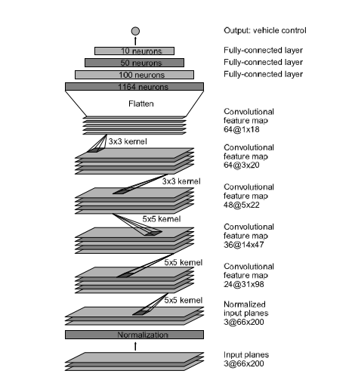

On training on the NVIDIA architecture, my car used to go off-track at sharp turns. Also, the model was complex. So, for simpler approach, I changed the NVIDIA architecture by removing one of the convolutional layers. Using this, I was able to drive the car on track in 4 epochs. The details of my model summary as given below.

#### 2. Attempts to reduce overfitting in the model

In order to overcome overfitting, I incorporated Dropout layers in the architecture. It greatly reduced the overfitting.

Also, I tried to keep the number of epochs to as minimum as possible, so that, my model gets well trained and it also does not over fit.

I also separated the data into training and validation with 80% as training data and 20% as validation data.

#### 3. Model parameter tuning

I have used the Adam optimizer for my model, as suggested in the project itself.

#### 4. Appropriate training data

The training data was chosen to keep the vehicle driving on the road. I generated my own data for this project. I generated for 2 laps in the forward direction and 2 laps in the reverse direction. The data consists of images from 3 different views, left camera, center camera and right camera. Each image in the generated data was used to create train my model.

### Model Architecture and Training Strategy

#### 1. Solution Design Approach

The overall strategy for deriving a model architecture was to initially test the model on the LeNet architecture. If the LeNet failed to give the required outcomes, then I moved on to try the NVIDIA architecture and finally with some changes in the NVIDIA architecture, I was able to get the results.

Initially, I started with using the LeNet architecture. I thought this model might be appropriate for this project because, it worked very well in the previous project. So, I hoped that with a little bit of changes, it should work good. However, on the 1st track the car went into the water or off-track very often. I normalized the images to improve the performance but it did not help a lot. So, I included a cropping layer, but still it did not improve the performance.

So, I moved on to try the NVIDIA architecture. I normalized the images and added a cropping layer along with the architecture. Then in order to improve my model, I had to remove one of the convolutional layer of the architecture. I also added dropout layers in the architecture in order to overcome overfitting. Instead of using the ‘ELU’ activation I used ‘ReLU’ activation on my model. At the end, I added an external dense layer to the architecture in order to have a single output.

In order to gauge how well the model was working, I split my image and steering angle data into a training and validation set. The model worked pretty well and gave very low training as well as validation loss.

In order to solve the overfitting problem, as I mentioned earlier, I used dropout layers in the NVIDIA architecture. Besides, I also generated augmented data, by flipping the training data images. I also used the left and right camera images with a correction factor of 0.22.

#### 2. Final Model Architecture

____________________________________________________________________________________________________

Layer (type) Output Shape Param # Connected to

====================================================================================================

cropping2d_1 (Cropping2D) (None, 90, 320, 3) 0 cropping2d_input_1[0][0]

____________________________________________________________________________________________________

lambda_1 (Lambda) (None, 90, 320, 3) 0 cropping2d_1[0][0]

____________________________________________________________________________________________________

convolution2d_1 (Convolution2D) (None, 43, 158, 24) 1824 lambda_1[0][0]

____________________________________________________________________________________________________

activation_1 (Activation) (None, 43, 158, 24) 0 convolution2d_1[0][0]

____________________________________________________________________________________________________

convolution2d_2 (Convolution2D) (None, 20, 77, 36) 21636 activation_1[0][0]

____________________________________________________________________________________________________

activation_2 (Activation) (None, 20, 77, 36) 0 convolution2d_2[0][0]

____________________________________________________________________________________________________

convolution2d_3 (Convolution2D) (None, 8, 37, 48) 43248 activation_2[0][0]

____________________________________________________________________________________________________

activation_3 (Activation) (None, 8, 37, 48) 0 convolution2d_3[0][0]

____________________________________________________________________________________________________

convolution2d_4 (Convolution2D) (None, 6, 35, 64) 27712 activation_3[0][0]

____________________________________________________________________________________________________

activation_4 (Activation) (None, 6, 35, 64) 0 convolution2d_4[0][0]

____________________________________________________________________________________________________

flatten_1 (Flatten) (None, 13440) 0 activation_4[0][0]

____________________________________________________________________________________________________

dense_1 (Dense) (None, 100) 1344100 flatten_1[0][0]

____________________________________________________________________________________________________

activation_5 (Activation) (None, 100) 0 dense_1[0][0]

____________________________________________________________________________________________________

dropout_1 (Dropout) (None, 100) 0 activation_5[0][0]

____________________________________________________________________________________________________

dense_2 (Dense) (None, 50) 5050 dropout_1[0][0]

____________________________________________________________________________________________________

activation_6 (Activation) (None, 50) 0 dense_2[0][0]

____________________________________________________________________________________________________

dropout_2 (Dropout) (None, 50) 0 activation_6[0][0]

____________________________________________________________________________________________________

dense_3 (Dense) (None, 10) 510 dropout_2[0][0]

____________________________________________________________________________________________________

activation_7 (Activation) (None, 10) 0 dense_3[0][0]

____________________________________________________________________________________________________

dense_4 (Dense) (None, 1) 11 activation_7[0][0]

====================================================================================================

Total params: 1,444,091

Trainable params: 1,444,091

Non-trainable params: 0

#### 3. Creation of the Training Set & Training Process

I created my own dataset for the training process. As mentioned earlier, I generated the dataset for 2 laps in forward direction and 2 laps in reverse direction.

The following things were done on the dataset:

* Used Left and Right camera images with correction factor for the steering angle

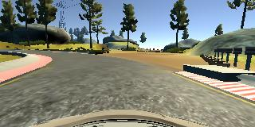

Original Image

* Flipped the images to create more variations in the dataset

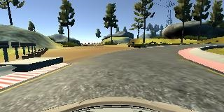

Flipped Image

* Cropped the dataset images in order to train only on the portions of the images which contained information for the road

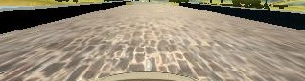

Cropped Image

* Normalized the dataset images